**Assignment**

**Learner Details**

* **Name: Nikhil k**
* **Enrollment Number: SU625MR004**
* **Batch / Class: June 2025 MERN**
* **Assignment: Simple Urban Cocoa – React Web Application.**
* **Date of Submission: 16/07/2025**

**1. Introduction**

**1.1 Purpose**

The purpose of the Urban Cocoa web application is to create a professional online platform for the Urban Cocoa brand. The application will showcase premium cocoa-based products, provide details for distributors/retailers, and help customers and businesses connect with Urban Cocoa easily.

**1.2 Scope**

The Urban Cocoa React project will serve as a marketing and informational platform for the business. The site will be responsive, modern, and built with React and TailwindCSS. It will highlight products, brand story, and allow users to contact or connect with the business for inquiries or distribution.

Key features include:

* Product catalog with images, pricing details, and descriptions.
* About Us page describing the brand and its mission.
* Contact/Inquiry form.
* Admin dashboard (for future expansion) to manage product listings and inquiries.
* Responsive design optimized for desktop and mobile.

**1.3 Definitions, Acronyms, Abbreviations**

* **React:** A JavaScript library for building user interfaces.
* **TailwindCSS:** A utility-first CSS framework for styling.
* **Admin Dashboard:** Section for internal management of product and business data.

**2. Overall Description**

**2.1 Product Perspective**

Urban Cocoa will be a standalone React application with static and dynamic content. Initially, it will focus on front-end product showcase and basic inquiry handling. Later, it can be extended with a backend (Node.js, Express, MongoDB) for full e-commerce or distributor management.

**2.2 Product Features**

* Homepage with hero section, brand highlights, and featured products.
* Product catalog with details such as name, description, and pricing.
* Contact form for inquiries.
* Admin dashboard (basic version) for product and inquiry management.
* Clean, premium UI reflecting the Urban Cocoa brand.

**2.3 User Classes and Characteristics**

* **General Users/Visitors:** Can view product information and contact Urban Cocoa.
* **Retailers/Distributors:** Can browse wholesale product details and send inquiries.
* **Admin:** Manages product listings and inquiries.

**2.4 Operating Environment**

* **Frontend:** React, TailwindCSS.
* **Browser Support:** Chrome, Edge, Safari, Firefox.
* **Future Backend (optional):** Node.js, Express, MongoDB.

**3. System Features**

**3.1 Homepage**

* Hero section with branding.
* Featured products.
* Quick links to catalog and contact.

**3.2 Product Catalog**

* Display all available products with image, description, and price.
* Option to filter/sort (future enhancement).

**3.3 Contact Page**

* Inquiry form (Name, Email, Phone, Message).
* Contact information of Urban Cocoa.

**3.4 About Us**

* Brand story, vision, and team background.

**3.5 Admin Dashboard (Phase 2)**

* Add/Edit/Delete products.
* View inquiries.

**4 Dataflow Diagram**

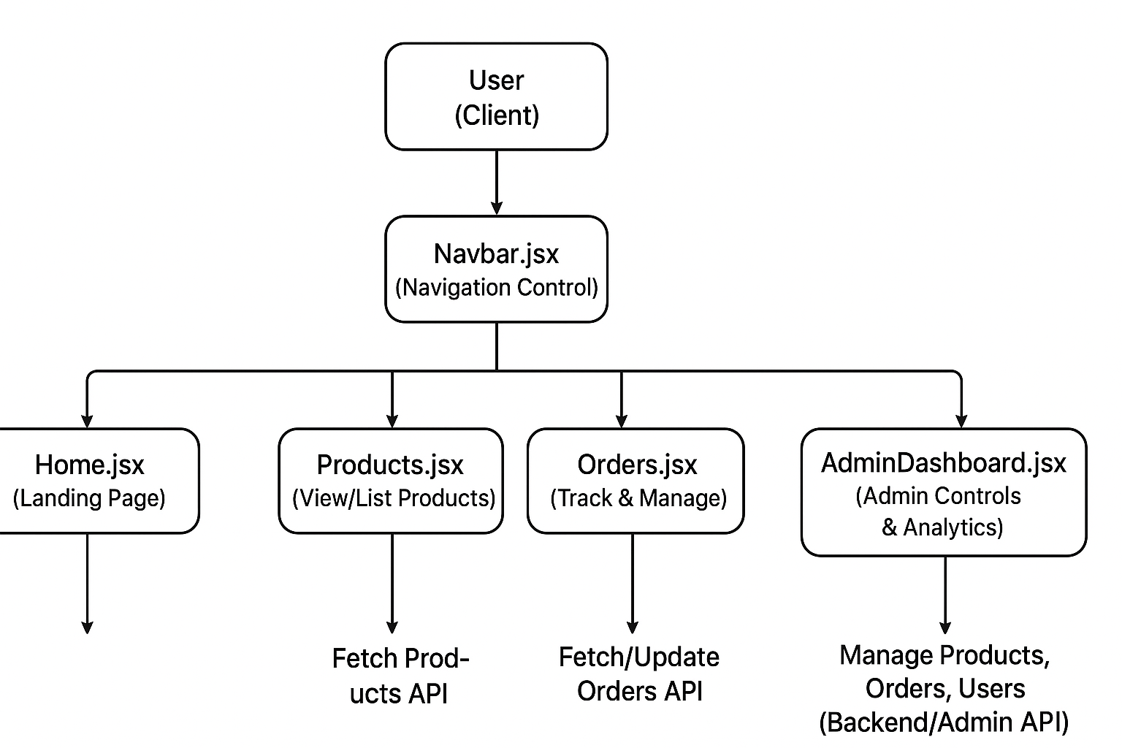

**5. Non-Functional Requirements**

* **Performance:** Website should load within 2 seconds on standard broadband.
* **Scalability:** Backend and database integration possible for future e-commerce features.
* **Security:** Secure handling of contact form data.
* **Usability:** Responsive design; mobile-first approach.
* **Maintainability:** Modular React component structure.

**6. Assumptions and Dependencies**

* Initial release will focus on a static product showcase with inquiry handling.
* Future versions may add authentication, payment gateway, and order management.
* Internet connection required for accessing the platform.